Volunteer Application Pack

Carers Leeds celebrates diversity and is an Equal Opportunities organisation, we welcome applications from all sections of the community, particularly BME and LGTBQ communities and/or people with disabilities.

Volunteer Digital Inclusion Befriender

Thank you for contacting us about volunteering at Carers Leeds. We are happy to enclose the following information:
- Carers Leeds Information
- Frequently Asked Questions
- Volunteer Selection Process
- Volunteer Role Description
- Carers Leeds Values and Behaviours

To apply for the role please complete and return our volunteer application form and monitoring information form.

To have an informal chat about the role before you apply, please do not hesitate to contact me on 07494 272 022.

Once you return your completed application to holly.wilkins@carersleeds.org.uk or 6—8 The Headrow, Leeds, LS1 6PT I will contact you to discuss your application.

I look forward to hearing from you shortly.

Yours sincerely,

Holly Wilkins
Digital Inclusion Co-ordinator

About us
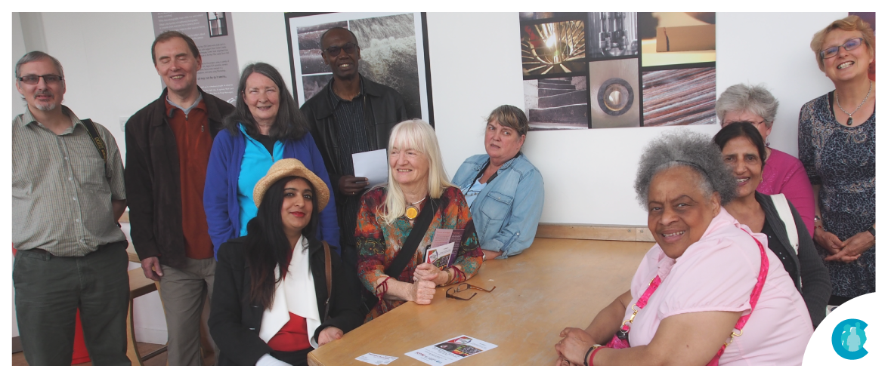

Carers Leeds
Carers Leeds is an independent charity that gives specialist and tailored support, advice and information to unpaid carers aged over 16. Established in 1996, our team of expert support workers are dedicated to improving the lives of thousands of carers in Leeds.

What is a carer?
A carer is someone who, without payment, provides help and support to a parent, partner, child, relative, friend or neighbour who could not manage without their help. This could be due to age, physical or mental health issues, substance misuse or disability.

What do Carers Leeds do? We deliver confidential one to one and group support that helps carers keep on caring. We are based in the centre of Leeds, and also offer support in local communities, over the phone and online.
For many carers, caring can be a rewarding and positive experience. However, there are many times when carers extra support, and that’s when we can help with:
- How carers are feeling - Finances, grants and benefits
- Managing at home - Rights at work
- Taking a break - Health and wellbeing

Volunteering Frequently Asked Questions
Can I volunteer if I am a carer?
Yes of course! We welcome your knowledge and experience. We would try to find a volunteer role that fits around your caring responsibilities.

Can I volunteer if my caring role has come to an end
Yes. Carers interested in volunteering for Carers Leeds will be expected to wait a minimum of 12 months following a significant bereavement, before being considered as a volunteer.
Will I be out of pocket?
No, travel expenses involved in volunteering will be reimbursed. For example, using your car to travel to your volunteering is currently reimbursed at 40p per mile.

Will I need to have a DBS check?
This depends on the volunteer role you are applying for. There are some roles which do require a DBS check and some which do not. If you do require a DBS check, this is provided by Carers Leeds.

Will I receive training for my volunteer role?
Yes, all volunteers have an induction to Carers Leeds and then specific training related to their role for example listening skills or how to support a carer.

Can I volunteer with Carers Leeds if I am claiming Job Seekers Allowance or Employment Support Allowance?
Yes, if you are receiving certain benefits, you are still allowed to volunteer. However, there are some rules that you need to be aware of to make sure that your volunteering doesn’t have an impact on the benefits you receive and you must notify your benefits adviser that you want to become a volunteer.

Volunteering Frequently Asked Questions

What if I need to take a break from volunteering?
If your circumstances change, don’t feel you have to leave. Talk to your supervisor about your needs and we might be able to arrange for you to have a break from volunteering for a while. And we will be happy to welcome you back when you’re ready.
What happens if I am not happy in my volunteer role?
If you are not happy in your volunteer role talk to your supervisor about how you are feeling. Your supervisor will explore how we can support you and/or what options are available if you are not happy.

What if I decide that volunteering at Carers Leeds isn’t for me?
All volunteers will be asked to complete a three-month trial period. At the end of this time, you can decide not to continue with the arrangement for whatever reason.

Selection Process for Volunteers

Person enquires about volunteering
|
Informal conversation/meeting to discuss volunteering offered (optional)
|
Receives application pack
|

Interview with Carers Leeds Volunteer Coordinator/Supervisor
|
The applicant informed if they have been successful or unsuccessful
An unsuccessful applicant is offered feedback and signposted to other organisations
|
References are taken up
|
DBS Check (where appropriate)
|
Welcome session to be attended
|
The signing of the volunteer agreement form and code of conduct
|
Introduction to the volunteer supervisor
|
Introduction to volunteering role
|
3-month Introductory period and completing essential training

VOLUNTEER ROLE DESCRIPTION

Role Title: Digital Inclusion Befriender

Volunteer Supervisor: Holly Wilkins

Location: Carer’s homes and/or community venues (i.e. cafes, libraries, community centres)

Hours/days: 60 minutes per week/every two weeks plus travel; this may vary dependent on the availability of the volunteer and carer; up to 12 befriending sessions

Role outline:

To support the digital inclusion co-ordinator and the digital inclusion project by offering one-to-one digital support to digitally excluded carers in a person-centred way. The aim is to reduce barriers and build up carers’ confidence in using IT equipment, which will enable them to get connected to online platforms (such as video calling; emailing; booking appointments; accessing information on the web). The role will empower carers to feel more independent and confident in their ability regardless of any perceived digital barriers they face. Accessing online platforms can open many doors for an individual that are beneficial to their caring role and can reduce current struggles associated with an inability to access online platforms.

Role tasks:

1:1 digital support based on the carer’s digital goals and interests which could include:
- Setting up devices
- Supporting individuals to learn the basics of a device (i.e. smartphone, laptop, or tablet)
- Supporting carers to use different apps and websites (i.e. games; Google; online shopping; apps to book GP appointments)
- Supporting carers to communicate with friends/family/support groups (i.e. via Zoom; WhatsApp; Email)
- Linking carers to digital support in the local community if required
- Ensuring the progress of support is noted and kept up to date

Main responsibilities and duties:

- To provide the digital support outlined by the project co-ordinator
- To report all safeguarding concerns
- Treating information seen and heard as confidential and sensitive
- Respecting different cultural values and working in a non-discriminatory way
- Volunteering within set guidelines and professional boundaries
- Attending regular meetings with your Volunteer Supervisor
- Completing the required training

Carers Leeds Values & Behaviours

At Carers Leeds we are one team, working together to benefit carers. We have a shared set of values and behaviours which guide everything we do. Values are the things we believe are important at Carers Leeds. Behaviours are what we expect staff, trustees and volunteers to do, to enact our values. These values and behaviours apply to how staff, trustees and volunteers interact with each other and the way we work with carers and external partners.

These values and Behaviours are continually reinforced from induction through supervision and team meetings.

- Integrity – we are honest, fair and speak up
- Accountability – we do what we say we will and take responsibility for our actions
- Inclusion – we value differences and take action to reduce exclusion
- Respect - we value and listen to each other
- Excellence - we continually improve through listening, learning and innovation
- Kindness - we are friendly, caring, and considerate
- Empowerment - we support, trust, and promote empowerment to make a difference

Respect for service user Confidentiality

The volunteer should always respect carers confidentiality and not divulge information unless sanctioned by the requirements of the role

