MEARS
CORONAVIRUS / COVID-19
Somali
Waa maxay CORONAVIRUS/ COVID -19?
Caabuqyada Ku dhaca sanbabada (Coronavirus) waa caabuqyo badan oo wada socda kuwaasoo aduunka dhan ku faafay. Caabuqyadaan waxay keeni karaan astaamo yaryar oo u dhaxeeya qandho iyo qufac ilaa astaamo aad u xun sida hargab xun, neefta oo ku dhagta qofka iyo iyo dhibaatooyin dhanka neefta ah.
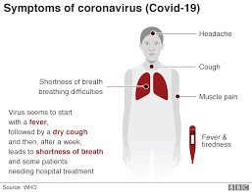
- Madax xanuun
- Qufac
- Murqo xanuun
- Qandho iyo daal
- Neefta oo kuyaraata
- Caabuqu wuxuu ku biloowdaa qandho, waxaana ku xigga qufac qalalan kadibna asbuuc kadib, wuxuu keenayaa neefta oo kugu dhagta bukaanada qaar ayaana u baahanaaya in isbitaal lagu daaweeyo.
Maxay tahay inaan sameeyo haddii aan aaminsanahy inan khatar ku jiro?
Haddii aad dhawaan safartay waxaad khatar dheeraad ah ugu jiri kartaa caabuqa COVID-19 (coronavirus). Xogta hoos ku qoran ayaa kaa caawinaysa qiimaynta inaad u baahan tahay qaadista talaabo dheeraad ah iyo in kale.
Laga bilaabo 2/3/20, meelaha khatartu ka jirto waa: Gobalka Hubei, Wuhan, China, Iran, Waqooyiga Talyaaniga, Thailand, Japan, Jamhuuriyada Korea, Hong Kong, Taiwan, Singapore, Malaysia, Macau, Vietnam, Cambodia, Laos, Myanmar iyo Tenerife. Si aad u hesho xogtii ugu danbaysay, booqo: https://www.gov.uk/guidance/coronavirus-covid-19-information-for-the-public#risk-level

WAA MUHIIM in dadka safraaya ee booqday mid kamid ah wadamada loo arko inay khatarta wayn ugu jiraan cudurka COVID-19 intii lagu jiray 14 kii maalin ee lasoo dhaafay, ay ku wargaliyaan Migrant Help ooy ka wacayaan 0808 801 0503 iyo Maareeyahaaga Guriyaynta MEARS sida ugu dhakhsaha badan, XATAA HADDII AADAN QABIN WAX ASTAAMAHA XANUUNKA AH. Waxay xaqiijin doonaan inaad hesho caawimaad kasta iyo daryeelka caafimaadka ee aad u baahan tahay si waafaqsan Tilmaamaha Caafimaadka Dadwaynaha.
Haddii aad u baahan tahay inaad la hadasho dhakhtar, wac 111 (England iyo Scotland) ama 0300 200 7885 (Northern Ireland) kadibna u sheeg qofka wicitaanka kaa qabta meesha aad dhawaan u socdaashay.

TALO BIXINTA CAAFIMAADKA DADWAYNAHA
GACAN KA GAYSO JOOJINTA FAAFIDA
Si lamid ah hargab xiliyeedka, isla talada caafimaadka bulshada ayaa qabanaaya fayriska Coronavirus (COVID-19) adoo haddii aad qufacdo ana hindhisto, ay tahay inaad adeegsato tiish si aad ugu daboosho afkaaga iyo sankaaga, si taxadar leh u tuur kadib markaad isticmaasho, kadibna dhaq gacmahaaga.
Marka hargabka iyo fayrisyada u eg ee caabuqa faafiya ay bilaabaan inay faafaan, qaabka ugu wayn ee looga hortagi karo in xanuunku sii faafo, waa nadaafada shaqsiga oo wanaagsan. Inaad si joogto ah u dhaqdo gacmahaaga waxay kaa caawinaysaa inaad ka hortagto hargabka iyo fayrisyada kale ee faafaaya.
Haddii aad xanuunsato aadna kashakido inaad qabto caabuqa Coronavirus (COVID-19) waa inaad guriga joogtaa aadna u sheegtaa Maareeyaha Gurigaaga sida ugu dhakhsaha abdan ee suuragalka ah. Ha u bixin banaanka ama ha booqan qof kale oo jooga dhismaha, Maareeyaha Gurigaaga ayaa dajin doona talaabooyin lagu dhawraayo faya qabkaaga.

Waad ku mahadsantahay wada shaqayntaada

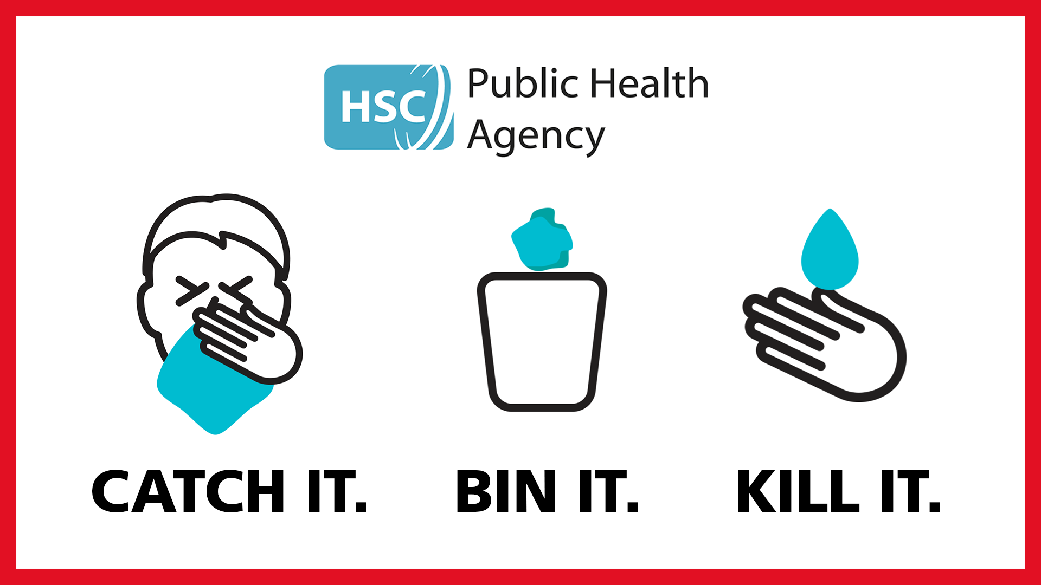
Dil.

Qashin ku rid.

Qabo

