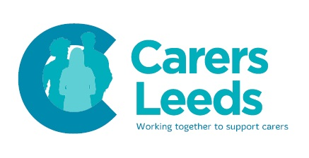
Office Administrative Assistant

Hours: 14 hours per week, over 2 days
Salary: £17,681 to £18,672
Contract: Permanent
Closing date: 12pm, Monday 28 October 2019
Interview date: W/c 4 November 2019

The role is to provide office administrative support services to Carers Leeds, a major charity in Leeds which provides support for unpaid carers in the city. The role is front of house, supporting our customer service and our office administration.
This includes:
- Reception cover
- Meeting and greeting visitors
- Coordinating meetings and events
- Training and supporting reception volunteers
- Dealing with office processes – mail, equipment, stationary
- Leading on the administration of specific projects
Excellent terms and conditions including:
- 25 days holiday pro rata
- DC Pension Scheme
- Great working environment
For an application pack please visit http://www.carersleeds.org.uk/vacancies
To apply please submit:
- A completed application form (No Agencies, CVs will not be accepted)
- A completed Equal Opportunities monitoring form, which is anonymous and will be separated from your application form upon receipt
Please email complete applications to: jobs@carersleeds.org.uk. Or post to: Carers Leeds, 6-8 The Headrow, Leeds, LS1 6PT
An enhanced DBS check will be required.
Carers Leeds celebrates diversity and is a LGBT friendly organisation. We welcome applications from all sections of the community. Application forms only, no CVs
Carers Leeds is a Limited Company Registered No. 3242065
Registered Charity No. 1058706

