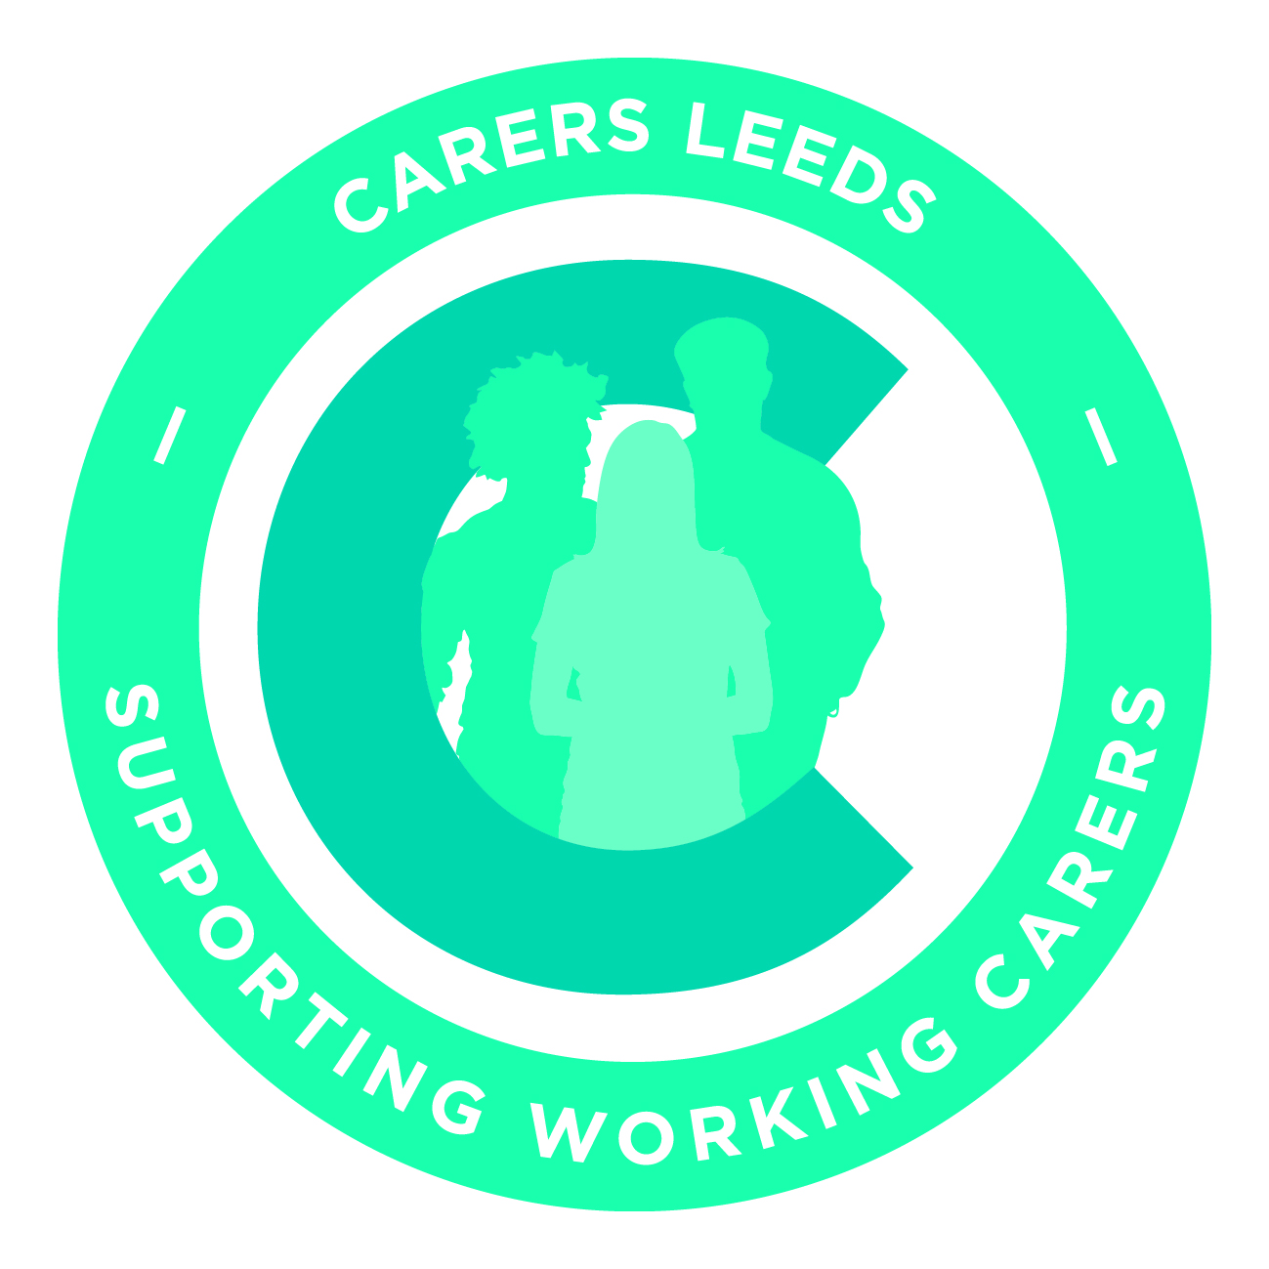
Notes for the Working Carer Employers Forum
From 6 February 2019, held at the Civic Hall Leeds

Forum members present:
Ian Brooke Mawson Leeds City Council
Mej Chaudhry Leeds City Council
Tom Gaffney British Gas
Stephanie Turner British Gas
Kyle Griffith University of Leeds
Russell Thomas Direct Line Group
Paul Morrin NHS Trust
Andy Moody DWP
Debra Creasser DWP
Alison Munro Leeds Teaching Hospitals
Nicky Lloyd Leeds College of Music
Eva Pearson Skills for Care
Sandra McLean NHS Digital
Bethan Johnston Yorkshire Building Society
Alex Mc Fadzean First Group
Jo Boyes First Group
Julie Bury Cafcass
Sally Donohoe Home office
Val Hewison Carers Leeds
Andrew Walsh Carers Leeds
Carrie Grey Carers Leeds
Madlen Sayar Carers Leeds

Apologies:
Helen Smith St Gemmas Hospice
Gillian Storm DWF
Virginia Saynor Environment Agency
John Bradfield West Yorkshire Police
Olivia Bell Irwin Mitchell
Linda Eades Civil Service Charity
Maxine Broomhead HMRC
Katie Wynn ASDA
Nabila Ayup Leeds Beckett University
Ian Baldwin Yorkshire Bank
Lucy Graham Forum Central
Helen Saunders Clarion
Rebecca Smith NHS England
Becky Edmundson Hainsworth

- Introductions and Apologies
We extended a warm welcome to the new members: NHS Digital, Yorkshire Building Society, First Group, Cafcass and Home office.

- Andrew gave a brief presentation on the Working Carers Service of Carers Leeds showing what it is about and how it works.

- Andrew announced to the meeting that Carers Leeds was formalising membership of the Employers Forum. Members would be receiving shortly a membership letter and some terms of reference for the group.

- Val gave an update on the future of Carers Leeds and the new carers contract that Carers Leeds has been awarded for the next 5 years. She mentioned a workshop that is now available that gives information about Hospital Care and Residential and Nursing Care. This is available for employers to access for their employees.
Val also mentioned a major initiative by Carers UK focussing on people giving up work because of caring. This was high profile in the media and Carers Leeds were involved in interviews for local radio and other media.

- Forum members introduced each other, outlining the carer support that they offer to their workforce. Andrew encouraged members to contact each other to explore areas of good practice, and he confirmed that the email addresses of members are shown when group emails are sent out from Carers Leeds.

- A networking break was built into the meeting and Members were encouraged to talk to other members to exchange information, successes and challenges.

- Andrew mentioned the in house free workshops we were offering and handed out a flyer containing information on these. Madlen and Carrie gave an update on the 1-2-1’s. They reported on the very positive feedback we have received from working carers showing how they value the opportunity to access support and information during work time and how they felt less stressed than they did before. Two sign up sheets were handed out for people to note their interest in either the workshops or the 1-2-1’s.

- Andrew spoke about the members only area of the website and asked if people would be willing to share their carers policies and other information with the other forum members in that way. The general view of the meeting was that they would all feel comfortable providing information on their own organisation for the members only area. Andrew confirmed that more details and passwords would be sent out soon.

- Andrew also mentioned the news letter which had been started in between the quarterly forum meetings and asked if that was of benefit. The general view was that it was of benefit to forum members.

- Andrew talked about the need to demonstrate to employers the impact of their support for working carers. He said that Carers Leeds measured what carers thought of the service we provide, but that it was up to employers to use information which shows for instance lower staff turnover, less stress and increased productivity as a result of supporting their working carers.

- The meeting split into smaller groups discussing to discuss 3 topics:

Topic 1- How we market to working carers the support we provide as employers

There was discussion about the different policies offered by employers, such as carers leave. The group also talked about how they identify carers within the workforce, as then support given can be targeted and measured. Communication media such as Yammer and other methods were suggested which allowed people to access carers networks from their phones. Another point raised was that carers information could be included in induction packages, which is also a good opportunity to ask if someone is a carer.

Topic 2 - Discussion on how employers with a workforce in Leeds, but who are part of a national organisation with some of the workforce elsewhere, can use the Working Carers services from Carers Leeds

The group discussed that the Carers Leeds approach to working carers, ie working through and with employers was not replicated elsewhere in the country. It was recognised therefore that sometimes national companies would use the service and support from Carers Leeds to develop the Leeds offices to be “trailblazers” for innovation in this areas which could then be rolled out to other sites in the country. There was the practical idea that if Carers Leeds was for instance providing management training to a Leeds office, there would be benefits from perhaps conference calling the training live to other sites.

People talked about The Mental Health First Aider movement and how this was something that started in one place and was now national
Discussions also included the idea of training trainers for working carers training sessions within their organisations.

Topic 3 - Re-entry into work following the death of a cared for.

Various scenarios were discussed. These had a common theme of carers looking for a new job or returning to their old job after time off for caring. The groups discussed how gaps in work history can reflect badly on someone trying to get into work again and how formal arrangements by the employer such as career breaks can really help. People discussed examples of how their employers accommodated returners, with, for example phased return, induction programmes, flexible working and other adjustments.
The group also agreed that there had to be a limit of what support and help even the most ethical and principled organisation could offer returners.

- Andrew asked the group what should be included on the members only part of the website. Suggestions brought forward included: internal care policies and guidance from individual employers, case studies from employers for successes, Toolkits from Carers Leeds for employers, new initiatives from Forum members, anything shared with carers within the organisation, internal surveys and marketing. Andrew confirmed that he would send the link and access code to the forum members and would be actively encouraging them to forward relevant material for inclusion.

- The next Forum meeting is held on Thursday May 16th and will be hosted by ASDA. More details will follow in due course. Further dates for Forum meeting for this year are Thursday Sept 5th and Wednesday December 4th. Please can you put those into your diaries and any volunteers for hosting the September or December forum please contact Madlen.

