Meeting of the Working Carers Employers Forum 18 July 2018  14.00 to 16.00  The Boardroom  Direct Line  The Wharf  Neville Street  Leeds  LS1 4AZ | 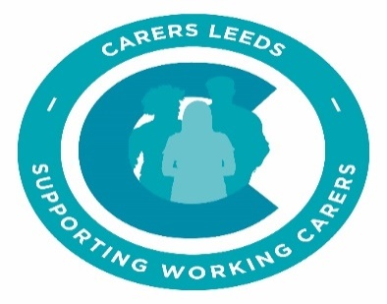

Items to discuss
- Introductions, including Madlen and any new Forum members

- apologies

- Updates on working carer employer issues in the city
  - Feedback on Carers Week
  - YEP Article
  - Citywide carers initiatives

- Progress on the Carers Leeds Working Carers package for employers –

  - Setting up one to ones in the workplace
  - Presentations and training for employers/managers
  - The toolkit for employers
  - Self assessment for employers
- Resources
  - Website, update on CL
  - Digital support for employers and carers
  - IAPT workshops for workplace wellbeing

- Case studies and successes

- Sharing ideas from the Forum:

- Why does our organisation buy in to supporting working carers?

- How are we convincing the senior leaders/board members/Trustees of the importance of supporting working carers

- How do we ensure our managers understand what support the organisation offers our working carers?

- How do we use carers forums at work – how effective are they.

- Additional item – refer to what people are doing already at start, and ask what others do around this. ls

- Any other items of interest (please notify us beforehand of any items)

