The Charity for Civil Servants CARER’S PASSPORT SURVEY, MAY 2017

In February 2017, 848 people who had received a Carer’s Passport during the first half of 2016 were invited to take part in a survey via Survey Monkey. 167 people completed the survey, a response rate of 20%.

Stress levels for respondents had improved after receiving a Carer’s Passport: 24% rated their stress levels as quite or very high compared to 65% beforehand.

How would you rate your stress levels before and after receiving a Carer’s Passport?
Before After
Very low 1.8% 5.4%
Quite low 4.2% 18.0%
Moderate 29.3% 52.7%
Quite high 36.5% 18.6%
Very high 28.1% 5.4%

The survey asked about the affect of people’s caring role on their health and wellbeing before and after receiving their Carer’s Passport. The results are shown in two separate charts.
Impact of caring role on health and wellbeing before receiving a Carer’s Passport
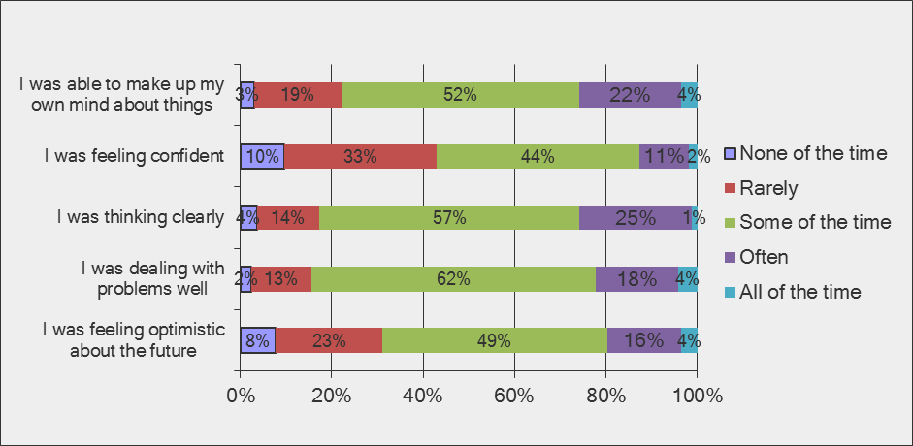

Impact of caring role on health and wellbeing after receiving a Carer’s Passport

Overall, these charts show that respondents’ health and wellbeing had improved since receiving a Carer’s Passport. Between 13% and 26% selected the answer options ‘Often’ or ‘All of the time’ before receiving a Carer’s Passport compared to 46-60% after receiving one. The Carer’s Passport appears to have helped particularly with thinking clearly, making up their own mind about things and dealing with problems well.
The survey asked how people’s caring role made them feel at work before and after completing a Carer’s Passport.
Impact of caring role at work before receiving a Carer’s Passport

Impact of caring role at work since receiving a Carer’s Passport

Overall, the impact of respondents’ caring role on their work had reduced since receiving a Carer’s Passport. Between 18% and 38% selected ‘Often’ or ‘All of the time’ before receiving the Carer’s Passport compared to 7-20% afterwards. The biggest changes were worrying about having a negative effect on their job, how colleagues perceive them, struggling with their workload, and affecting performance at work and physical health.
Respondents were asked what they were doing or considering doing at work before receiving a Carer’s Passport and what the Carer’s Passport had actually enabled them to do.
Before completing a Carer’s Passport were you doing or considering doing any of the following?

The greatest number of respondents were using unpaid time off for caring responsibilities (47%), requesting a change in working patterns (43%), using sick leave for caring responsibilities (22%) or looking for another job (22%).
Did your Carer’s Passport enable you to do any of the following?
The Carer’s Passport had enabled people to do a number of things at work, mainly to continue in their job (48%), to seek alternatives to sick or unpaid leave (26%) and request a change in working patterns (22%).
15% of respondents reported that they had approached organisations that were recommended for support when they were given their Carer’s Passport. 31% were already in touch with relevant organisations, 29% had not had the time and 25% had not noticed this information.
95% said they would recommend the Carer’s Passport to a friend or colleague in a similar situation, and a few had already done this.
Other comments about how the Carer’s Passport had helped at work:
Helped to take time off at short notice or choose working hours to suit
It gives me confidence that if my wife is taken ill she can ring me at work and I am able to return home immediately to look after her. This only happens occasionally but can be covered.
It helps when you need to take time off from work at short notice.
It has helped me in that I can choose the hours I want to work around my caring responsibilities. I don’t feel as pressurised to do the hours the department wants me to do.
I would highly recommend it, has helped me such a lot to know if I need time away from work at short notice I can have it without any objections by a line manager.
Sets out the impact caring may have on work for current and future managers
Management take persons with caring responsibilities more seriously if they have a Passport. Much more vulnerable in workplace without this. Possession of Passport makes management feel that you have been prepared to consult with the union and would seek union help if necessary.
I have recently moved to work for another manager. The Carer's Passport has meant that I haven't had to spend time discussing my caring responsibilities with my new manager as it is already documented in my personal file.
You need to make your manager aware of your careering responsibilities and this is ideal rather than have to do this face-to-face as it can be upsetting.
I have recommended this to so many of my colleagues in similar situations. I hate having to explain to new team leaders/colleagues and the team who decide our working hours why I work the hours I do. I just have to ask them to look at my Carer’s Passport and it's been smooth sailing ever since.
Some reported that it had made no or little difference
The Passport has had no effect on my personal circumstances. Leave/time-off is restricted due to daily planning of resources and attendance, and caring responsibilities are not taken into account when time off is requested.
My line manager still does not recognise the caring issues and has said I should use flexi hours when I need to care for my mum which is disappointing.
Maybe some advice about your legal rights as a primary carer would help.

