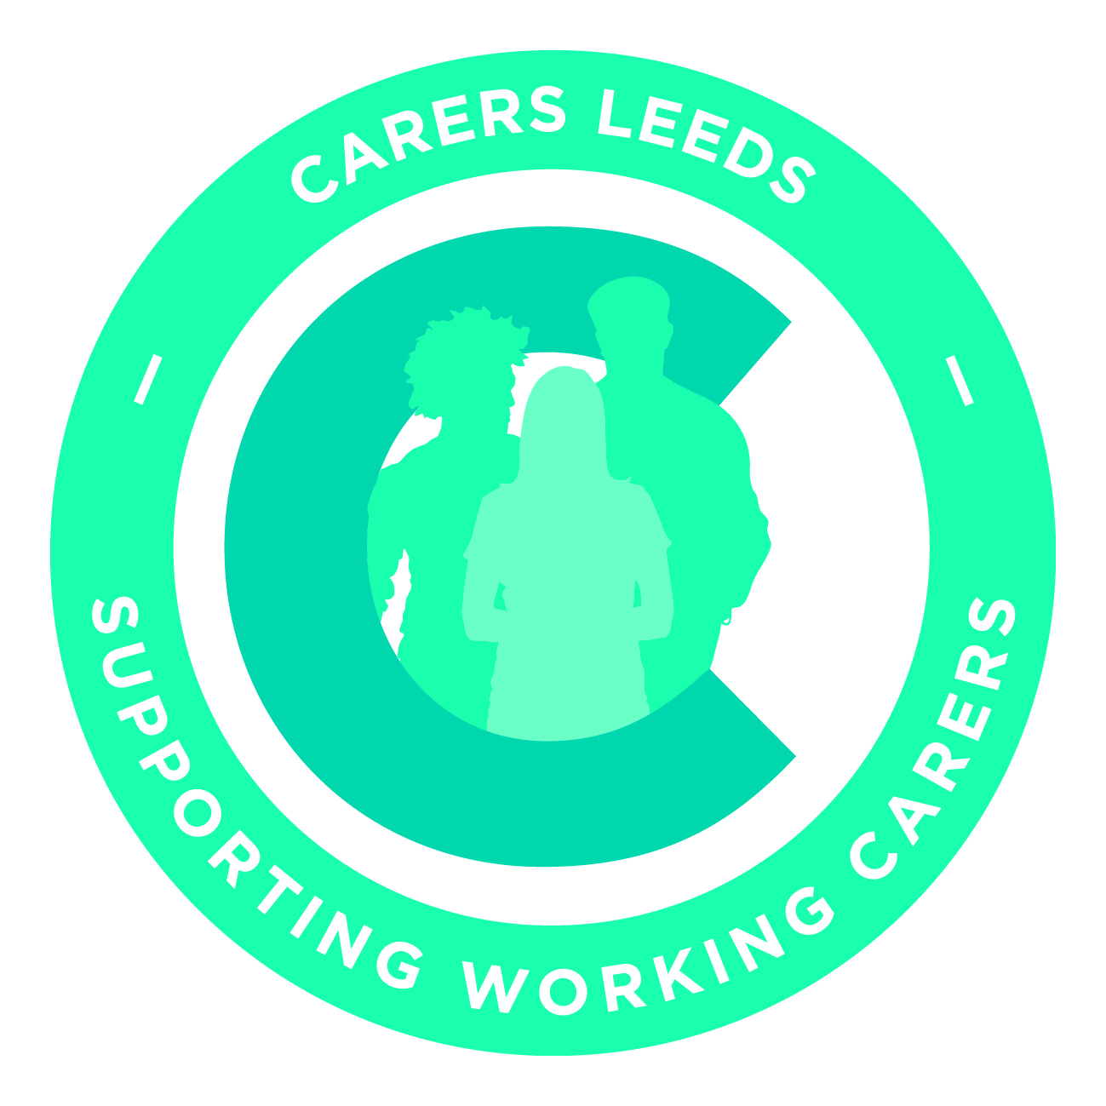
Employer Survey: How working carer friendly are you as an employer?
All of the evidence suggests that if you support your working carers there will be a direct impact on the organisation in terms of morale, employee retention, reduced stress, increased performance and the overall performance of the organisation.
Take our carer friendly self-assessment to see how supportive you are.
- Identification of Working Carers | Yes/No/partially
Is there clarity in the organisation about what is meant by the term “carer”?
Is there a system in place to enable carers to recognise or identify themselves if they choose to:
- through having a question about caring in employee surveys?
- through specific employee surveys and consultation on carers?
- via the recruitment and induction process?
- via employee appraisals or one to ones?
- through a voluntary carers register?
- Other methods?
Does your organisation know how many carers you have in the workforce through:
- Statistics of how many have declared their caring role?
- Statistics of how many have reduced their hours because of caring roles?
- Statistics of how many have left the organisation because of caring roles?
- Other methods?

- Carers Policies and Processes | Yes/no/partially
Are carers recognised within your organisations HR policies?
Is there a statement which makes specific reference to supporting carers within the organisation?
Is there knowledge of and adherence to the minimum statutory employment rights for working carers?
Is there an explicit carers policy in place or a separate section within HR policies which recognises carers as a specific group?

- Workplace Support | Yes/no/partially
Is information on external sources of support and services for
carers available?
Do you provide external advice and support sessions via Carers Leeds for individuals during working hours?
Are options for carers to benefit from additional practical support in the workplace identified:
- Paid carers leave
- Unpaid carers leave
- Career breaks
- Carers “passports”
- Flexible working
- Temporary part time working
- Time off for appointments
Can carers access other practical workplace support?

- Communication, Awareness and Training | Yes/no/partially
Are policies and available workplace support communicated to all levels of the workforce?
Are awareness raising activities undertaken in the workplace:
- Awareness training for managers?
- Awareness training for all employees?
Does the organisation engage in wider community based awareness raising activities or employer forums to communicate the business?

- Peer Support | Yes/no/partially
Are carers supported to engage with other carers?
- On line forums
- Internal working carers forums
Are carers supported by and do they support other carers?

